Mohawk College

Assignment 4– Sequence

COMP-CO835-05

Justin Challis (001137680)

Bhatt Saumilkumar Pramodbhai (000838181)

1. Provide a concrete example from Automated Teller Machines

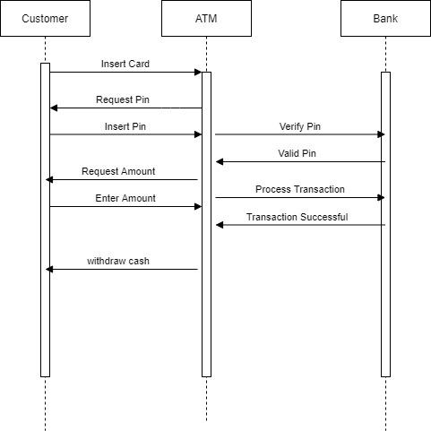

1. What are Sequence diagrams and what are they used for specifically?

A sequence diagram is a type of interaction diagram because it describes how—and in what order—a group of objects works together. These diagrams are used by software developers and business professionals to understand requirements for a new system or to document an existing process. A sequence diagram simply displays the order in which things interact or the order in which these interactions occur. A sequence diagram can also be referred to as an event diagram or an event scenario. Sequence diagrams show how and in what order the components of a system work together.

1. How are Sequence diagrams different from Class diagrams? Do they complement Class diagrams or serve as a totally separate set of diagrams? Explain using an example.

* A class diagram shows a set of classes, interfaces, and their relationships and illustrates the static design view of a system, while a sequence diagram shows the sequence of actions that occurs in a system and illustrates the dynamic view of a system.
* A class diagram is a UML diagram that illustrates classes, interfaces, and their associations. And, it is used for static object modeling.
* A sequence diagram is a UML diagram that illustrates how objects (The instance of a class) interact with each other. And, it is used for dynamic object modeling.
* Sequence diagrams and Class Diagrams serve as a totally separate set of diagrams.
* For example, in the class diagram, we define entities and their relationship with each other and in the sequence diagram, we define processes which different actors perform.
* An example could be that a supermarket has a produce section and in that produce section, there are a variety of fruits and vegetables. The layout would be a class diagram labeling the different products and laying out where they are located and perhaps how they relate to each other. A Sequence diagram would show a customer as an entity and the steps necessary to both navigate and obtain their desired products.

1. What purpose do the forward and backward horizontal connections serve? Explain and provide a concrete example.

* The horizontal lines tell the story of how the two entities relate or communicate with one another. It’s almost like a little story in itself. If we look at the diagram concerning the ATM, we notice that the user puts in their card and the machine requests their pin. The horizontal arrows paint this picture pretty clearly.

1. Draw a comprehensive Sequence diagram for full-time student registration at Mohawk College.

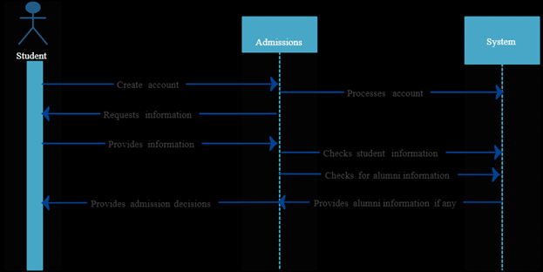

References

1. <https://knowhow.visual-paradigm.com/uml/class-and-sequence-diagram-share-model/>
2. <https://conceptdraw.com/a3135c3/p1/preview/640/pict--bank-atm-uml-sequence-diagram-atm-sequence-diagram>
3. https://www.google.com/